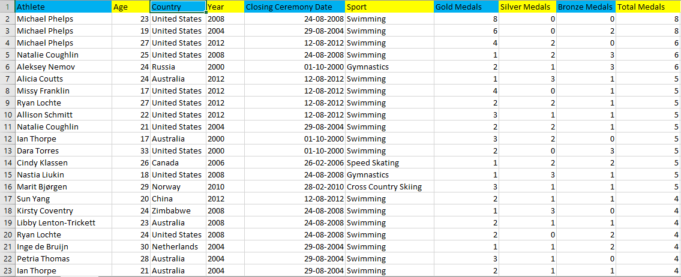**Practical no: 1**

* The corresponding pie chart shows that the athlete **“Michael Phelps”** won maximum number of gold medals in the sport he played.

**Athlete by gold medal**

* The column chart shows that most of the athlete won “**2 silver medals”** in the sport.

**Athlete by silver medal**



* The corresponding chart shows that **“swimming”** is the sport that is played the most.

**Athlete by sport**

* The corresponding bar graph shows that **“United states”** is the country which won highest number of total medals (gold, silver and bronze) as compared to other countries.

**Country by total medals**